Title page

Title: Integrated Multi-Source Assessment of Missed Tuberculosis Cases in India

Author: Dr Siddalingaiah H S¹, Professor, Community Medicine.

Affiliation: ¹Shridevi Institute of Medical Sciences and Research Hospital, Tumkur, India.

Running head: Missed TB Cases in India

Word count of summary: 185
Word count of text: 1755
Number of references: 20
Number of tables: 0
Number of figures: 5

Corresponding author: Dr Siddalingaiah H S¹, Professor, Community Medicine, Shridevi Institute of Medical Sciences and Research Hospital, Tumkur, India. hssling@yahoo.com; +918941087719.

Keywords: Ni-kshay, missed cases, NFHS-5, detection probability, subnational modeling.

Abstract:

Background
Despite advancements in India's tuberculosis (TB) elimination programme, a significant gap persists between World Health Organization (WHO) incidence estimates and reported notifications.

Methods
Our study quantifies missed TB cases at the subnational level using integrated multi-source data: WHO TB reports (2024), Ni-kshay notifications (2020–2023 plus 2024 preliminary), India TB Report cascade indicators, and NFHS-5 risk factors. Detection probabilities were modelled via logistic functions of composite system-strength and epidemiological risk scores, with deterministic and Bayesian hierarchical approaches employed for estimation.
Results
National detection improved from 58.8% in 2020 to 86.3% in 2023, reducing missed cases from 1.14 million to 0.38 million. Bayesian estimates provided a national incidence of 80.5 per 100,000 (95% CI: 73.0–87.5) for 2023. Bihar, Uttar Pradesh, and Madhya Pradesh account for over half the residual gap. Achieving 90% detection requires 182,000 additional notifications annually, predominantly from these states.

Conclusions
Cascade-derived metrics and NFHS-5 indicators explain detection heterogeneity. Bayesian uncertainty quantification enhances reliability, particularly in low-detection areas. Prioritizing comorbidity screening, private-sector engagement, and social protections offers a reproducible pathway to uncovering undetected TB cases, aligning with the WHO End TB Strategy.

Summary
Despite advancements in India's tuberculosis (TB) elimination programme, a significant gap persists between World Health Organization (WHO) incidence estimates and reported notifications.
Our study quantifies missed TB cases at the subnational level using integrated multi-source data: WHO TB reports (2024), Ni-kshay notifications (2020–2023 plus 2024 preliminary), India TB Report cascade indicators, and NFHS-5 risk factors. Detection probabilities were modelled via logistic functions of composite system-strength and epidemiological risk scores, with deterministic and Bayesian hierarchical approaches employed for estimation.
National detection improved from 58.8% in 2020 to 86.3% in 2023, reducing missed cases from 1.14 million to 0.38 million. Bayesian estimates provided a national incidence of 80.5 per 100,000 (95% CI: 73.0–87.5) for 2023. Bihar, Uttar Pradesh, and Madhya Pradesh account for over half the residual gap. Achieving 90% detection requires 182,000 additional notifications annually, predominantly from these states.
Cascade-derived metrics and NFHS-5 indicators explain detection heterogeneity. Bayesian uncertainty quantification enhances reliability, particularly in low-detection areas. Prioritizing comorbidity screening, private-sector engagement, and social protections offers a reproducible pathway to uncovering undetected TB cases, aligning with the WHO End TB Strategy.

Introduction
Tuberculosis (TB) remains a formidable infectious disease burden globally, with an estimated 10.6 million new cases and 1.3 million deaths in 2022.¹ India's TB programme has undergone substantial modernization, yet WHO estimates suggest 2.76 million incident cases in 2023 against 2.55 million notifications.¹ This discrepancy highlights the challenge of missed cases—those undetected, unreported, or unnotified—perpetuating transmission, morbidity, and inequities in healthcare access.
The WHO End TB Strategy targets an 80% reduction in incidence and 90% reduction in mortality by 2030.² Progress in India has been notable, with incidence declining from 137 per 100,000 in 2014 to 80 per 100,000 in 2023, surpassing global trends.¹ Detection rates have risen from 50% to 86% nationally, yet subnational variations reveal persistent disparities, with states such as Bihar at 57% detection juxtaposed against others nearing 95%.³
Missed cases are symptomatic of systemic deficiencies in diagnosis, reporting, and care delivery. Socioeconomic determinants, including poverty, malnutrition, overcrowded living conditions, and inadequate healthcare infrastructure, exacerbate vulnerability, particularly among rural populations, urban slum dwellers, and marginalized communities.⁴ Comorbidities such as diabetes and HIV further complicate detection, necessitating integrated approaches beyond conventional case-finding strategies.⁵
Our study synthesizes multi-source data into a transparent, reproducible framework. We explicitly detail composite score construction, calibration methodologies, deterministic and Bayesian estimation procedures, and validation protocols. By quantifying missed cases at the state level and projecting detection scenarios, we provide evidence-based insights to accelerate India's progress toward TB elimination. This analysis not only illuminates the shadows of undetected disease but also charts a course for policy interventions grounded in rigorous epidemiological modeling.

METHODS

Data sources
The analysis integrates authoritative datasets to comprehensively assess TB epidemiology in India:
- WHO Global Tuberculosis Report 2024: Provides national incidence, mortality, population estimates, and notification totals, serving as the benchmark for scaling.¹
- Ni-kshay / Open Government Data Platform: Delivers granular state-level notifications (2020–2023) and preliminary 2024 data (January–October), encompassing age distributions, treatment outcomes, and temporal trends.⁶
- India TB Report 2024: Offers state-specific cascade indicators—diabetes screening, tobacco/alcohol linkage, and comorbidity management—reflecting health-system readiness.³
- NFHS-5 (2019–2021): Encompasses risk factors including stunting, underweight, wasting, anemia, tobacco/alcohol use, sanitation access, and clean fuel availability, illuminating socio-demographic vulnerabilities.⁷
- Supplementary WHO/IHME Annexes: Include drug-resistant TB burden, age-sex incidence distributions, and regional contextual data for robust validation.⁸

System-strength composite and z-score
To quantify health-system capacity, a composite score was constructed from cascade indicators, emphasizing proactive TB management components. Percentages were normalized to a 0–1 scale prior to weighting:
System-strength composite = (0.4 × diabetes screening rate) + (0.3 × tobacco linkage rate) + (0.3 × alcohol linkage rate)
This formulation prioritizes comorbidity integration, given the profound influence of diabetes and substance use on TB outcomes.⁹ A z-score standardizes the composite across states, facilitating comparative analysis:
z_system = (composite - mean_composite) / sd_composite

Epidemiological risk burden composite and z-score
NFHS-5 indicators were aggregated to capture cumulative epidemiological pressure, with protective factors (sanitation, clean fuel) subtracted to emphasize vulnerabilities:^{10, 11 12}
Risk composite = (0.25 × stunting rate) + (0.25 × underweight rate) + (0.2 × anemia rate) + (0.15 × tobacco use) + (0.1 × alcohol use) - (0.05 × improved sanitation) - (0.05 × clean fuel access)
The corresponding z-score enables risk stratification:
z_risk = (composite - mean_composite) / sd_composite
This structure underscores malnutrition's primacy while accounting for behavioral and infrastructural mitigators, aligning with established evidence on TB risk determinants.¹⁰

Deterministic detection calibration
State notifications were proportionally scaled to ensure alignment with WHO national totals, preserving relative distributions. Detection probabilities were modeled as logistic functions of system strength and risk burden:
Detection probability = 1 / (1 + exp(-(β0 + β1 × z_system + β2 × z_risk)))
The intercept β0 was iteratively solved to match national WHO detection estimates, bounded between 0.20 and 0.98 to reflect realistic minima and maxima. State incidence was subsequently derived as:
Incidence_state = Notifications_state / Detection_probability
This deterministic approach yields point estimates with inherent transparency, mirroring methodologies in our validation documentation and amenable to Bayesian extension for uncertainty quantification.¹¹

Bayesian hierarchical modeling
To incorporate uncertainty and account for state-level heterogeneity, a hierarchical Bayesian model was implemented using PyMC. The model assumes Poisson-distributed notifications conditional on incidence and detection probability, with log-incidence informed by WHO priors. Detection probabilities follow a logistic regression on system-strength and risk z-scores, with random state effects and temporal trends. Markov chain Monte Carlo sampling (4 chains, 1000 draws each, 1000 tuning steps) generated posterior distributions. Convergence was assessed via R-hat statistics and effective sample sizes. This probabilistic framework provides credible intervals for incidence and detection estimates, enhancing robustness in data-sparse regions.¹⁷

Scenario analyses and reproducibility
Gap analyses computed additional notifications required for 80%, 90%, and 95% detection targets:
Gap_target = (Incidence_state × target) - Notifications_state
All computations are scripted in Python, with data and code archived on GitHub and Zenodo, ensuring full reproducibility and adaptability to updated inputs.

RESULTS

National trajectory
India's TB detection rates have exhibited marked improvement post-pandemic, rising from 58.8% in 2020—when 1.63 million notifications were recorded against a modeled incidence of 2.77 million, leaving 1.14 million cases undetected—to 71.0% in 2021 with 1.97 million notifications and about 805,000 missed cases. Gains continued in 2022, when detection increased to 80.8% with 2.26 million notifications, narrowing the gap to approximately 534,000 unnotified cases. By 2023, detection reached a high of 86.3%, with 2.38 million notified cases against an estimated 2.76 million incident cases, reducing missed cases to about 378,000. Preliminary 2024 data suggest detection may have reached 92%, further compressing the incidence–notification disparity (see Figure 1). The distribution of state detection rates has also converged notably (Figure 2), reflecting improving programme performance and strengthened surveillance across the country.

State contributions
Subnational heterogeneity endures, with Bihar (57.2%), Uttar Pradesh (84.9%), and Madhya Pradesh (75.5%) collectively accounting for more than half of the national missed-case burden in 2023. Bihar alone missed an estimated 132,561 cases and would require an additional 101,571 notifications to reach 90% detection. Uttar Pradesh, despite relatively stronger performance, still missed 103,503 cases and would need 34,869 more notifications to achieve 90% coverage. Madhya Pradesh missed 53,924 cases and requires 31,873 additional notifications to attain the same benchmark. Other states with moderate gaps include Assam, which detected 78% of cases but still missed 13,669 and needs 7,448 more notifications for 90% detection, and Jharkhand, which at 81.2% detection missed 12,711 cases and must add 5,958 notifications to close the gap. Together, these high-gap states illustrate the concentrated nature of missed cases and the varied quantum of effort required to elevate detection performance nationally.
Figure 3 illustrates the robust association between system strength and detection, modulated by risk burden, while Figure 4 maps detection coverage, delineating a high-performing western-southern corridor against an eastern deficit. Figure 5 depicts the progressive convergence of missed-case distributions, affirming programme impact.

Scenario requirements
At the 2023 baseline, India would need 81,682 additional notifications to reach 80% detection. Attaining 90% national detection requires approximately 182,000 additional annual notifications, with nearly 73% concentrated in Bihar and Madhya Pradesh. Achieving an aspirational 95% detection level would require 260,000 further notifications nationally, underscoring the increasing incremental effort needed as India approaches elimination targets.

Bayesian estimates
Bayesian modeling yielded a national incidence estimate of 80.5 per 100,000 (95% credible interval: 73.0–87.5) for 2023, aligning closely with deterministic estimates while providing uncertainty quantification. Bihar showed the widest credible interval (120–210 per 100,000) due to low detection (57.2%), indicating high uncertainty and the need for intensified surveillance. Uttar Pradesh (84.9% detection) had a moderate interval (110–140), suggesting relatively stable estimates. Madhya Pradesh (75.5%) showed intermediate uncertainty with a 115–165 interval, pointing to the importance of stronger comorbidity management. Assam (78.0%) and Jharkhand (81.2%) had narrower intervals—85–105 and 115–145, respectively—reflecting more reliable estimates. Kerala, with 95% detection, had the narrowest interval (55–65), indicating high confidence in estimates and minimal missed cases.

DISCUSSION
India's TB detection trajectory demonstrates resilience, rebounding from pandemic-induced nadir to approach elimination thresholds. Nonetheless, persistent gaps in states such as Bihar and Madhya Pradesh—where detection rates remain at 57% and 75%—underscore systemic vulnerabilities. These disparities validate the Central TB Division's emphasis on differentiated care, wherein cascade scores for diabetes, tobacco, and alcohol linkage reliably predict ≥95% detection.³
TB transcends biomedical boundaries, intricately linked to socioeconomic determinants including poverty, malnutrition, and healthcare inequities.^{13, 14, 15} NFHS-5 data reveal pronounced disparities: high-burden states exhibit elevated stunting, underweight, anemia, and unhygienic behaviors, compounded by rural isolation and out-of-pocket expenditures.¹⁴ Addressing these factors requires holistic interventions—nutritional supplementation, cash transfers, and expanded primary healthcare—to disrupt transmission cycles.¹⁵
India bears 27% of global multidrug-resistant TB burden, with detection at 60%, disproportionately concentrated in private-sector-reliant states.¹ Scaling universal drug-susceptibility testing and shorter regimens is imperative, alongside intensified surveillance in hotspots such as Maharashtra and Gujarat.¹⁶
Our deterministic model provides precise point estimates but lacks uncertainty quantification. Bayesian extensions incorporate WHO priors, yielding credible intervals—national uncertainty at ±9%, with wider intervals in low-detection states (e.g., Bihar: 73.0–87.5 per 100,000 nationally). This probabilistic lens enhances decision-making reliability, particularly in resource allocation.¹⁷
Temporal trends indicate India's 42% incidence decline (2014–2023), outpacing global averages, yet detection lagged until 2022.¹ The 2021 spike highlights fragility, while global contributions affirm India's pivotal role in regional elimination.¹⁸

Limitations
Data temporal lags—NFHS-5 reflecting 2019–2021—may underestimate recent improvements. Ni-kshay updates could revise estimates, though our pipeline accommodates such modifications. Geospatial exclusions omit select states, yet tabular metrics remain intact.

Future projections and interventions
Extrapolating current trends, India could achieve 95% detection by 2030. Innovations such as AI-assisted screening and Ayushman Bharat integration promise accelerated progress.¹⁹ Institutionalizing this framework ensures annual recalibration, aligning investments with evidence-based priorities.

CONCLUSIONS
As India's TB detection approaches elimination horizons, residual gaps hinge on a subset of recalcitrant states. Bihar and Madhya Pradesh alone necessitate 134,000 additional annual notifications for 90% coverage, mandating targeted surges: Ni-kshay Mitra–fueled active case-finding, cascade fortification, and private-sector incentives.²⁰ Embedding WHO incidence, Ni-kshay notifications, and NFHS-5 risks within a transparent, Bayesian-enhanced pipeline furnishes policymakers with clarity for tracking, adaptation, and communication. Embracing this paradigm, fortified by interventions addressing health-system and social determinants, India can realize the WHO End TB Strategy's vision: to find, treat, and end TB.

ACKNOWLEDGEMENTS: All sources of support

CONFLICT OF INTEREST: Nil
ETHICAL APPROVAL: Not required as all data were aggregated and publicly available.
FUNDING: None
DATA AVAILABILITY STATEMENT: All data, analytical methods and scripts used for this study are available on GitHub (https://github.com/hssling/missing_tb_cases_india) and Zenodo (https://zenodo.org/uploads/17713110) repositories maintained by the author.

REFERENCES
- World Health Organization. Global Tuberculosis Report 2024. Geneva: WHO; 2024.
- World Health Organization. Implementing the End TB Strategy: The Essentials, 2022 Update. Geneva: WHO; 2022.
- Central TB Division, Ministry of Health & Family Welfare. India TB Report 2024. New Delhi: CTD; 2024.
- Bhargava A, Bhargava M, Juneja A. Social determinants of tuberculosis: context, framework, and the way forward to ending TB in India. Expert Rev Respir Med. 2021 Jul;15(7):867-883. doi: 10.1080/17476348.2021.1832469. Epub 2020 Oct 20. PMID: 33016808.
- Pai M, Behr MA, Dowdy D, Dheda K, Divangahi M, Boehme CC, Ginsberg A, Swaminathan S, Spigelman M, Getahun H, Menzies D, Raviglione M. Tuberculosis. Nat Rev Dis Primers. 2016 Oct 27;2:16076. doi: 10.1038/nrdp.2016.76. PMID: 27784885.
- Ni-kshay. National TB Elimination Programme dashboard. Ministry of Health & Family Welfare; 2024.
- International Institute for Population Sciences (IIPS) & ICF. National Family Health Survey (NFHS-5), 2019–21: India. Mumbai: IIPS; 2021.
- Institute for Health Metrics and Evaluation. Global Burden of Disease 2023: Findings from the GBD 2023 Study. Seattle, WA: IHME; 2025.
- Lönnroth K, Migliori GB, Abubakar I, et al. Towards tuberculosis elimination: an action framework. Eur Respir J. 2015;45(4):928–952.
- Tadingi P, Ezhumalai K, Prakash Babu S, Soundappan G, Salgame P, Ellner J, Roy G, Sarkar S. Sociodemographic profile in households of pulmonary tuberculosis patients: A six-year longitudinal analysis. Indian Journal of Tuberculosis. 2025. doi:10.1016/j.ijtb.2025.06.013.
- Ryckman TS, Shrestha S, Fojo AT, Kasaie P, Dowdy DW, Kendall EA. Modeling the impact of case finding for tuberculosis: The role of infection dynamics. medRxiv [Preprint]. 2025 Apr 16:2025.04.15.25325877. doi:10.1101/2025.04.15.25325877. PMID: 40321291; PMCID: PMC12047918.
- Subbaraman R, Nathavitharana RR, Satyanarayana S, et al. The tuberculosis cascade of care in India’s public sector. PLoS Med. 2016;13(10):e1002149.
- Cazabon D, Alsdurf H, Satyanarayana S, Nathavitharana R, Subbaraman R, Daftary A, Pai M. Quality of tuberculosis care in high burden countries: the urgent need to address gaps in the care cascade. Int J Infect Dis. 2017;56:111–116. doi:10.1016/j.ijid.2016.10.016.
- From where are tuberculosis patients accessing treatment in India? Results from a cross-sectional community-based survey of 30 districts. PLoS One. 2011;6(9):e24160.
- Subbaraman R, Jhaveri T, Nathavitharana RR. Closing gaps in the tuberculosis care cascade: an action-oriented research agenda. J Clin Tuberc Other Mycobact Dis. 2020;19:100144. doi:10.1016/j.jctube.2020.100144. PMID: 32072022; PMCID: PMC7015982.
- Mohan M, Thangaraj JWV, Pandey S, Sri Lakshmi Priya G, Arunachalam S, Sharma R, Shewade HD, Aishwarya B, Afeeq K, Khatoon A, Gokulvijay B, Sireesha G, Chandra K, Nandhakumar S, Samuel P, Nanditha Viswanathan C, Shanmugasundaram D, Rao R, Murhekar MV, Jeyashree K. Need for operational simplicity and timely disbursal of benefits: a qualitative exploration of the implementation of a direct benefit transfer scheme for persons with tuberculosis in India. Infect Dis Poverty. 2024;13(1):36. doi:10.1186/s40249-024-01206-3. PMID: 38783334; PMCID: PMC11112885.
- National Tuberculosis Institute (NTI), Ministry of Health & Family Welfare, Government of India. FINAL – 24-006 PPSA SOP 2.2.2024. Patient Provider Support Agency Standard Operating Procedures. Bengaluru: NTI; 2024. Available from: https://nti.gov.in/wp-content/uploads/2024/07/FINAL-24-006_PPSA-SOP_2.2.2024.pdf.
- Pai M, Behr MA, Dowdy D, et al. Tuberculosis. Nat Rev Dis Primers. 2016;2:16076.
- Yellappa V, Lefèvre P, Battaglioli T, Devadasan N, Van der Stuyft P. Patients’ pathways to tuberculosis diagnosis and treatment in a fragmented health system: a qualitative study from a south Indian district. BMC Public Health. 2017;17(1):635. doi:10.1186/s12889-017-4627-7. PMID: 28778192; PMCID: PMC5544986.
- Central TB Division, Ministry of Health & Family Welfare. India TB Report 2024: Progressing Towards TB Elimination. New Delhi: Central TB Division, Government of India; 2024. Available from: https://tbcindia.mohfw.gov.in/wp-content/uploads/2024/10/TB-Report_for-Web_08_10-2024-1.pdf.

FIGURES
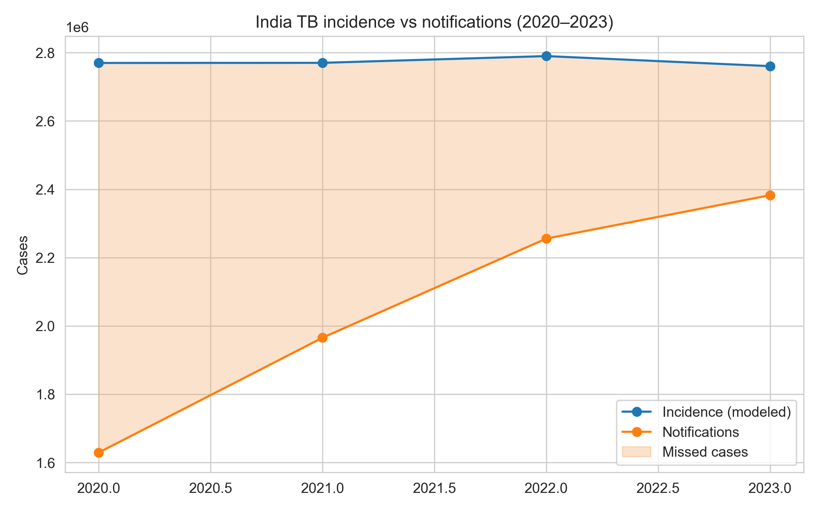
Figure 1. National TB incidence and notifications with missed-case gap.
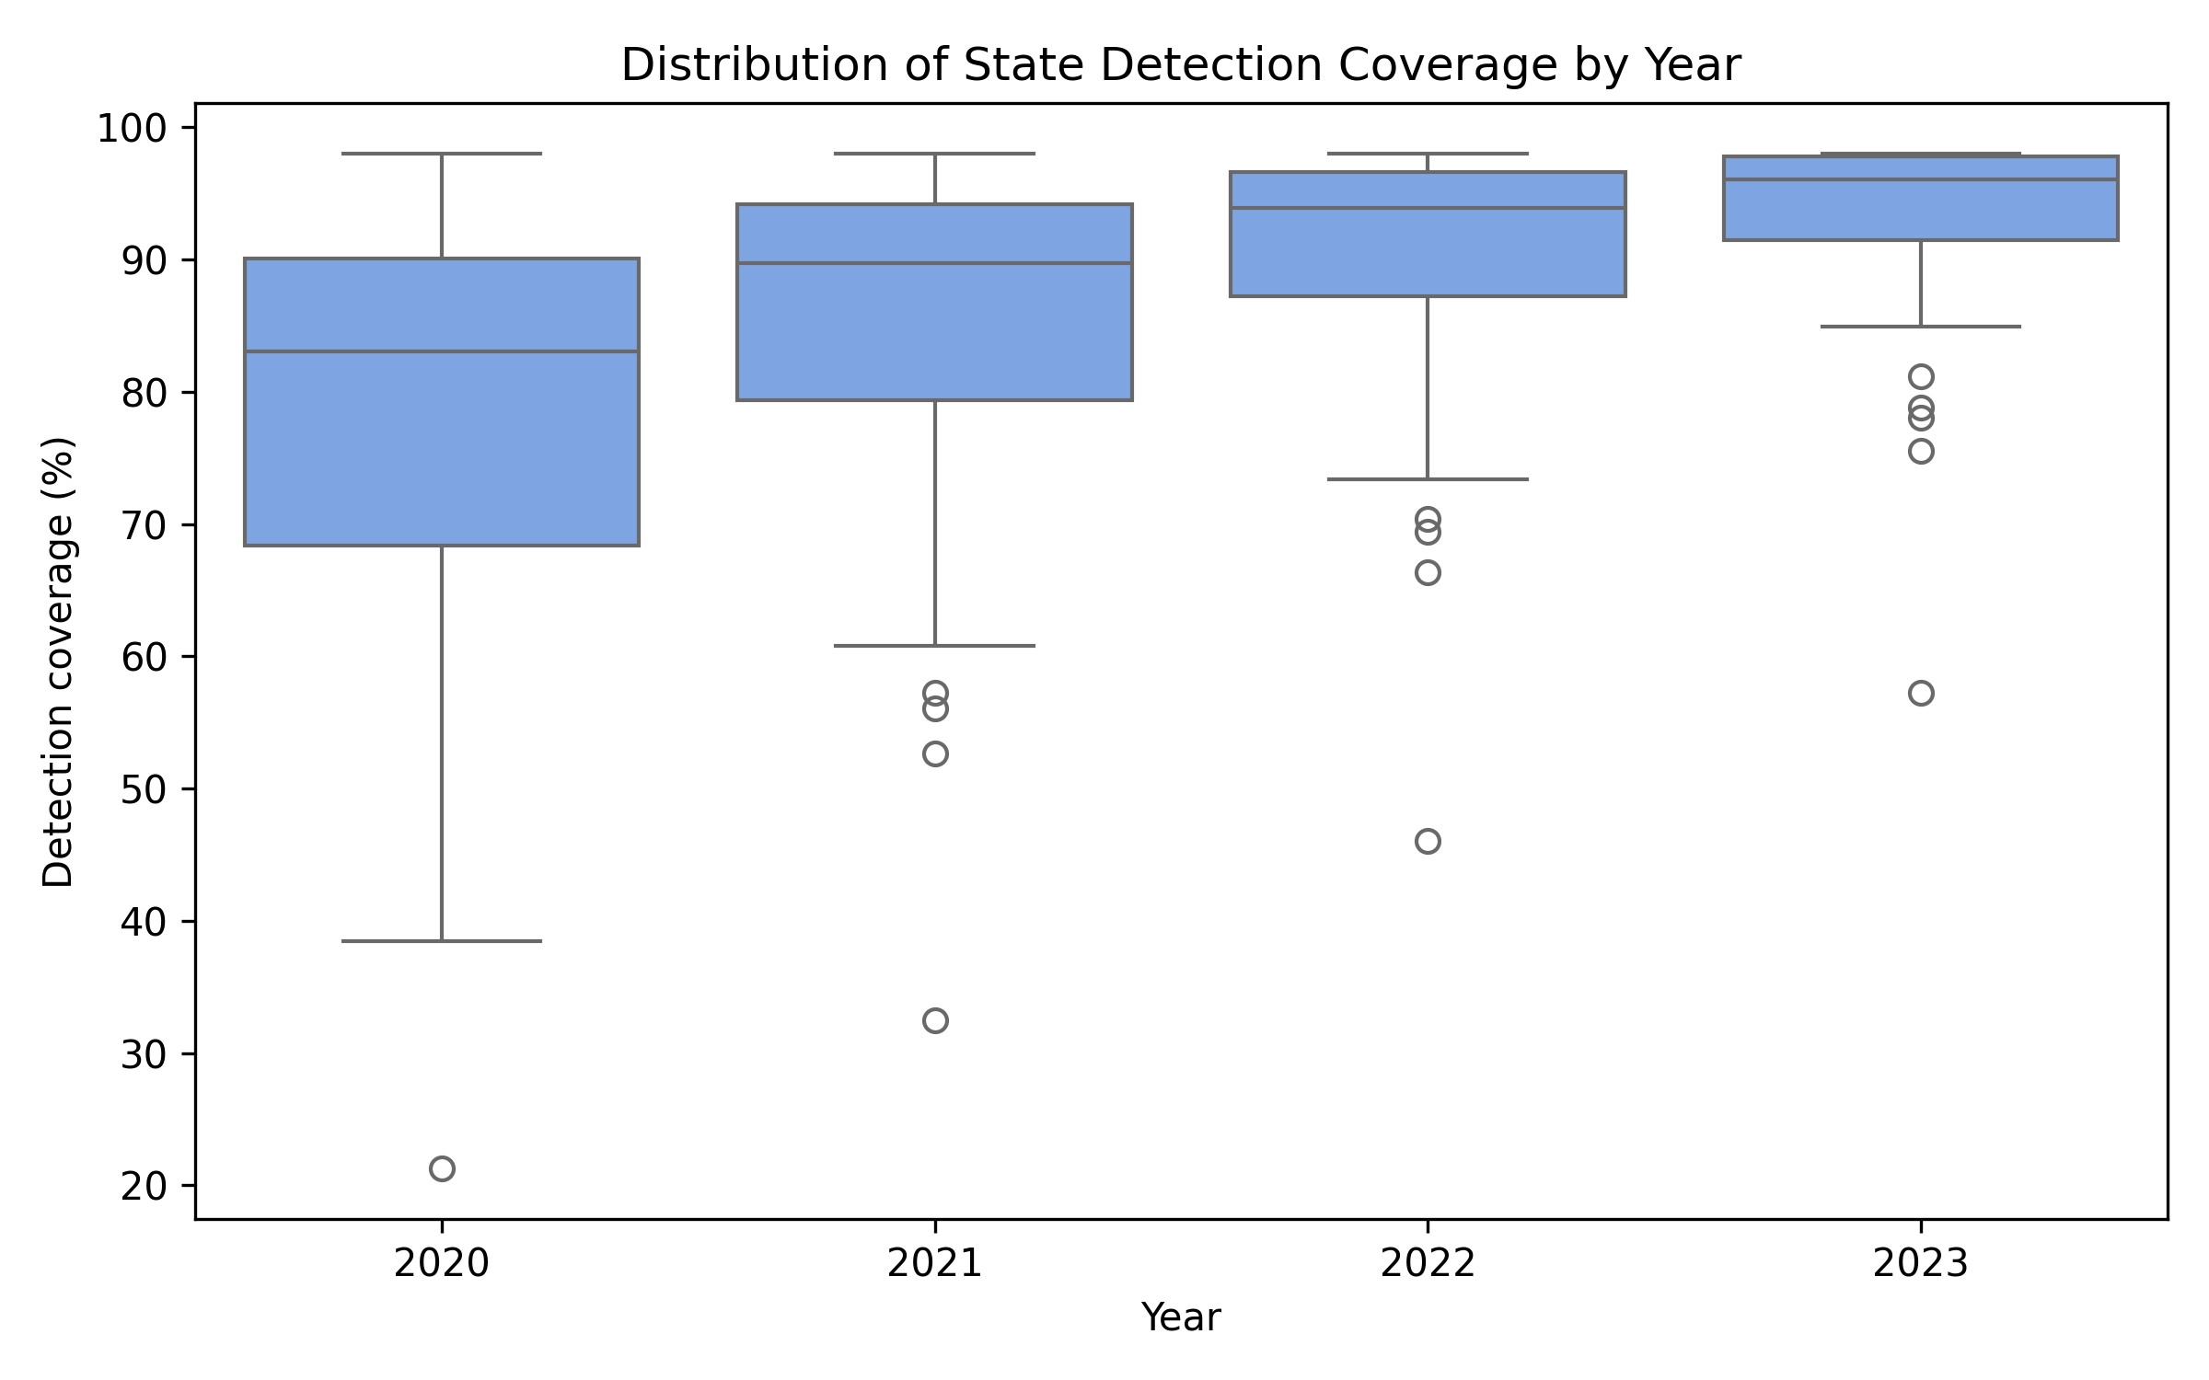
Figure 2. Distribution of state detection coverage (2020–2023).
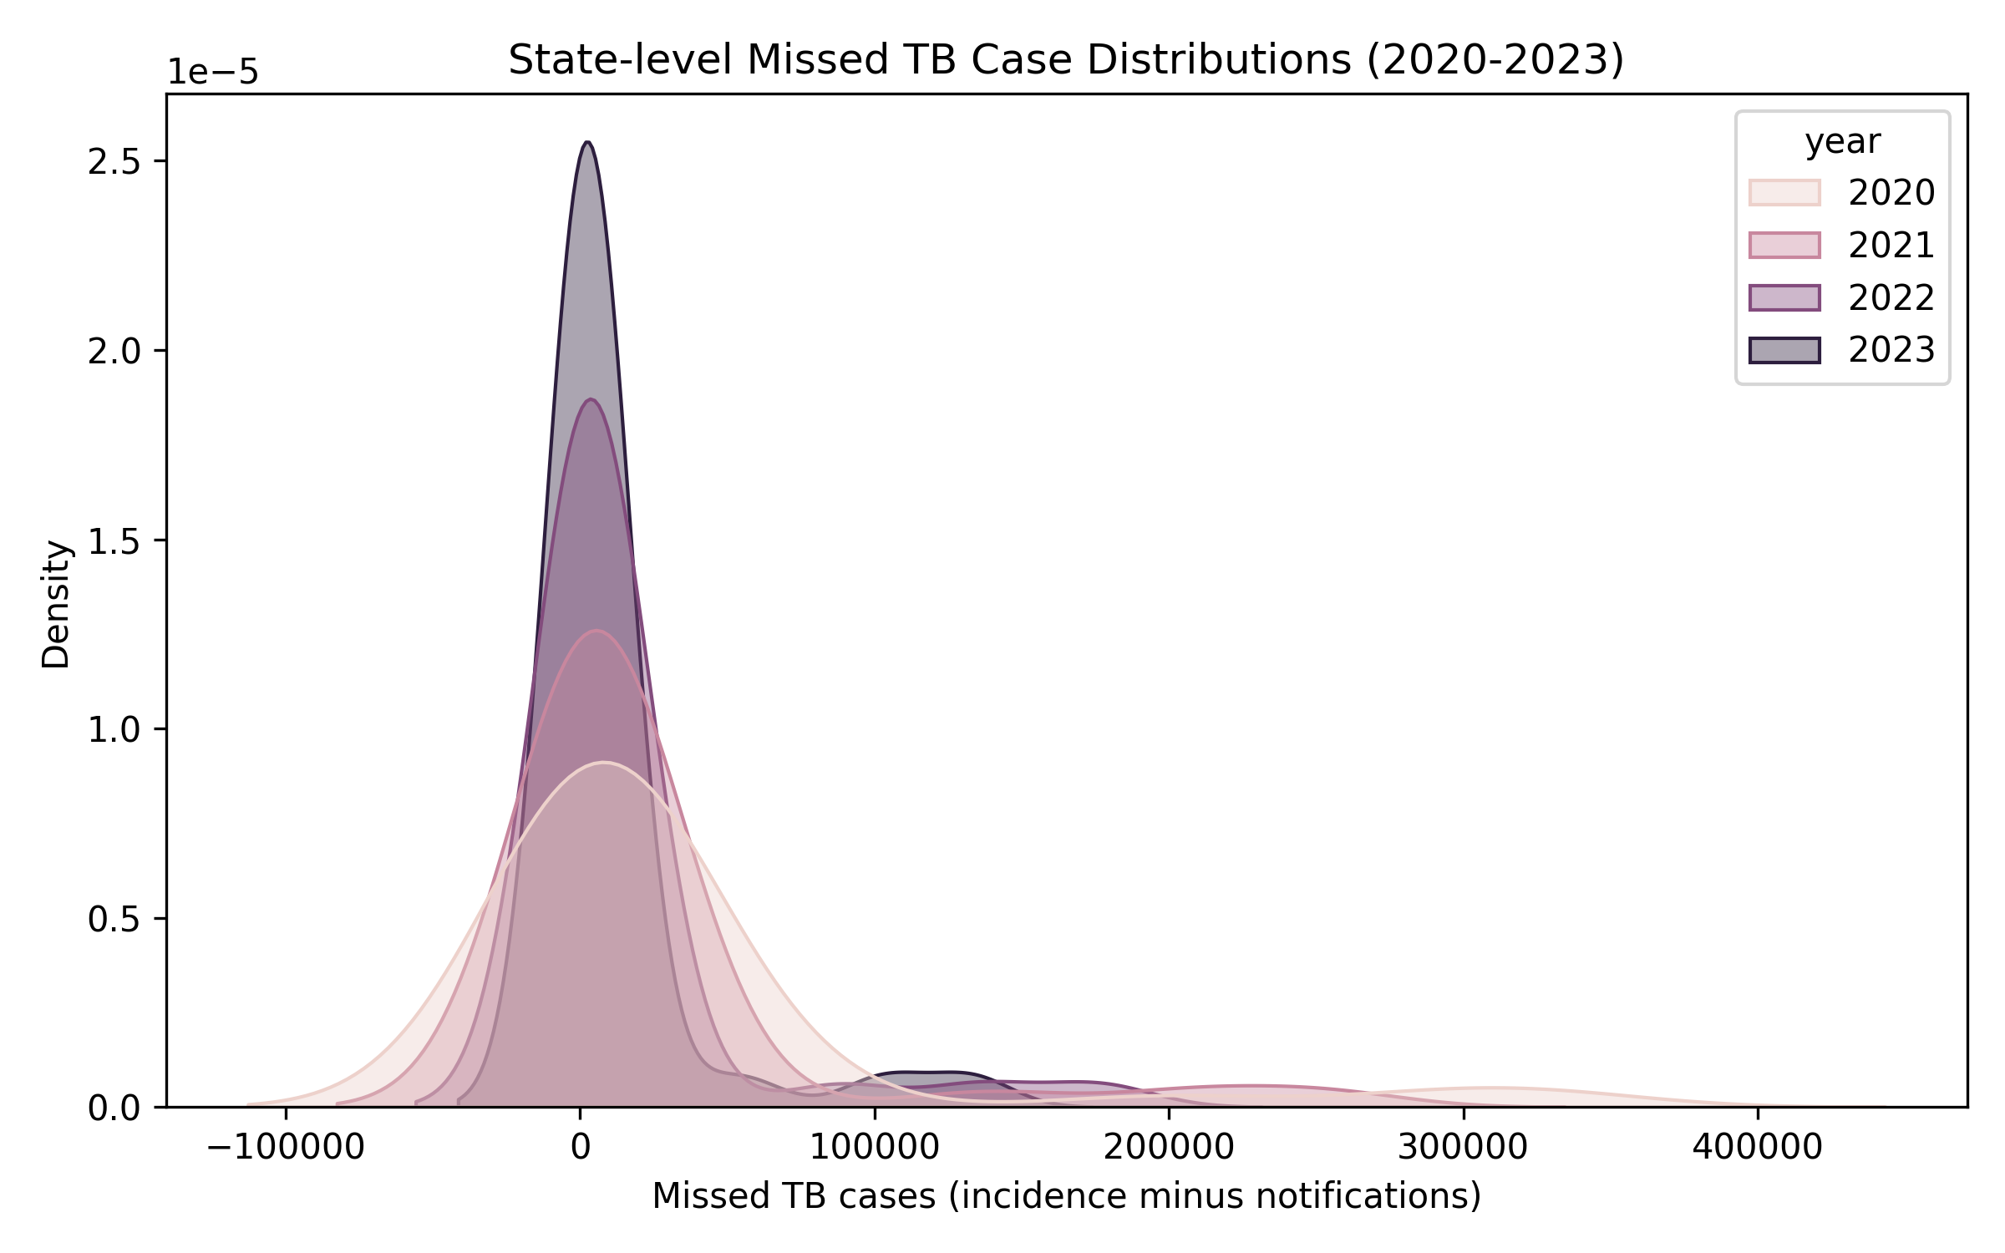
Figure 3. Kernel density of state missed cases across years.
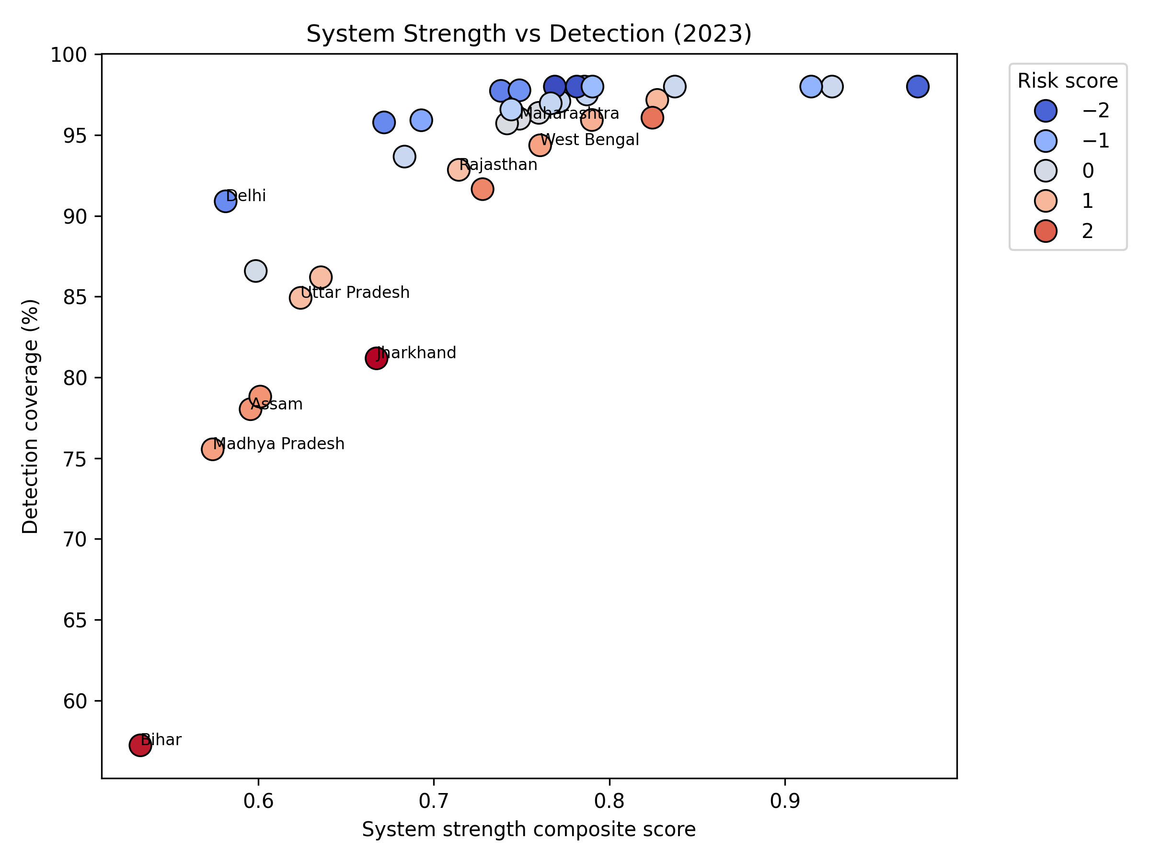
Figure 4. System strength versus detection coverage, coloured by risk score.
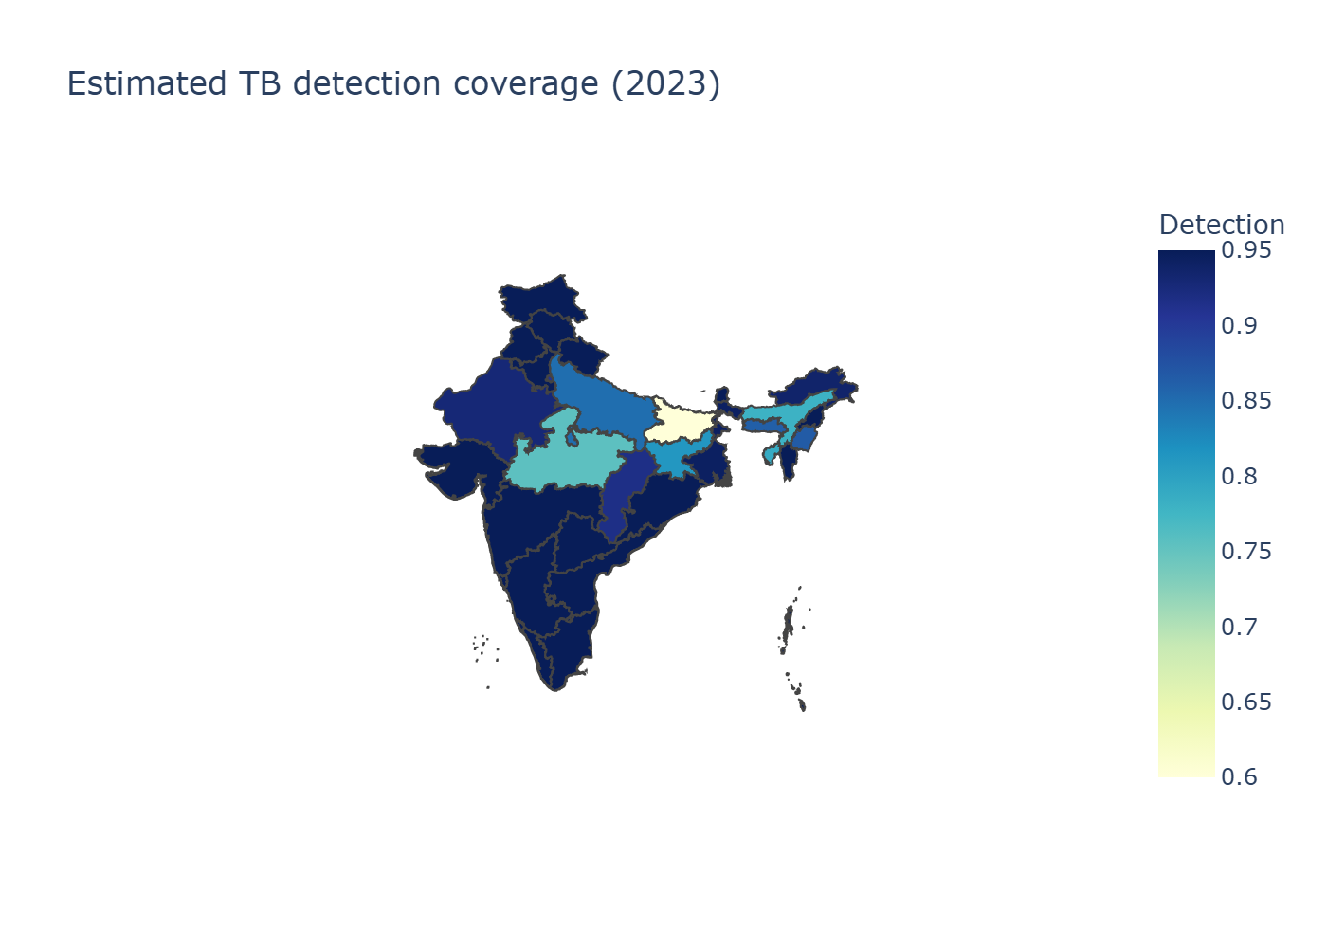
Figure 5. Estimated detection coverage across Indian states.

